Safe operation of reduced capacity cranes

Guidance Note

Document No:

Date: 24/05/2021

What has happened

NOPSEMA has identified three recent incidents where offshore cranes were operated in a reduced lifting capacity (i.e. de-rated) with inadequate controls to prevent overloading. Upon identification of structural integrity and corrosion defects the cranes had been removed from service. However, they were subsequently put back into service and operated in de-rated capacity without appropriate management of the hazards associated with defects.

Offshore cranes are Safety Critical Equipment (SCE) as their failure can result in a serious incident. Globally, the offshore industry has seen many serious incidents involving cranes failing or loads dropped, resulting in the loss of life, damage to equipment, and the release of hydrocarbons with safety and environmental consequences. The risk is real, significant and cannot be ignored.

The revision of hazard controls, such as de-rating of an offshore crane, is a serious undertaking as the starting point is equipment with compromised controls. Additionally, the de-rating process is usually conducted under operational pressures potentially leading to consideration of compromised or ineffective controls.

NOPSEMA receives a significant number of notifications of accidents and dangerous occurrences related to cranes and lifting operations. Crane operations are inherently high-risk operations and any reduction in controls further increases the risk. The structural integrity and the temporary de-rating of lifting equipment is of concern NOPSEMA, particularly where risk to personnel involved in offshore lifting operations are not being properly managed.

As a result, NOPSEMA is issuing this safety bulletin to remind all operators of their legal responsibilities to take all reasonably practicable steps to ensure that any equipment, such as lifting equipment, is safe and does not pose a risk to health and safety. Additional risk mitigation strategies must be considered when the lifting capacity of an offshore crane is affected by structural and/or mechanical integrity issues.

What could go wrong?

Operating a crane with compromised structural integrity may cause the crane to collapse and/or a load to be dropped. There is an increased risk to the safety of the personnel involved in lifting operations if a crane is operated with compromised structural integrity, irrespective of its capacity. Operators of hydrocarbon production facilities identify dropped objects as a cause of loss of containment resulting in a Major Accident Event (MAE) or Major Environmental Event (MEE).

Why did these incidents occur?

Where the capacity has been reduced to allow the crane to operate safely within its compromised structural integrity, the crane’s control system to prevent overloading of the crane must reflect the newly de-rated capacity and must include interim control measures.

Offshore crane standards such as EN13852-1, API 2C, DNVGL-ST-0378 and BS EN 7121 mandate that cranes be equipped with a rated capacity indicator for all load hoists and that gives a continuous display to the crane operator of the actual hook load and the boom angle/radius. The indicator is also required to display the rated capacity at that boom angle/radius for the selected significant wave height and a warning signal when the actual hook load approaches and/or exceeds the rated capacity. This control system must be aligned to the crane capacity, including any de-rating.

In the three incidents described above, the facility operators had deemed the cranes to be critical for the ongoing safe operation of the respective facilities. The de-rating tasks were identified and actioned through the operator’s Operational Risk Assessment (ORA) and implemented through additional controls to mitigate risks associated with structural integrity issues. A flow chart is provided to show a typical process where a structural defect is assessed on a crane and actions are taken to assure ongoing safety.

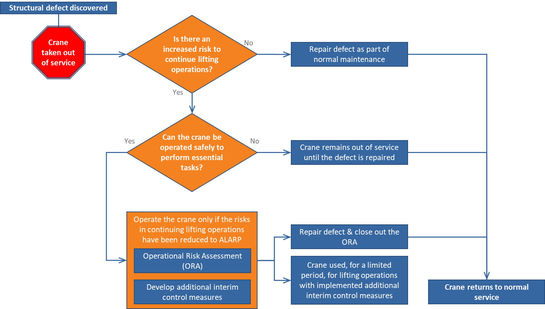

NOPSEMA has noted the following:

* When structural defects were found, most operators implemented their unique ORA processes and engaged with the crane’s manufacturers to determine and/or verify the de-rated capacity of the crane. Whilst the risks were being assessed, the operators took the cranes out of service and returned them to service at de-rated capacities.
* In all instances, the additional interim control measures implemented to prevent overloading of the crane were found to be administrative controls only. There were no engineering hazard controls implemented and there were no modifications made to the cranes control systems to reflect the reduced capacities. The cranes overload prevention systems were then made ineffectual.

Examples of additional interim control measures are provided below:

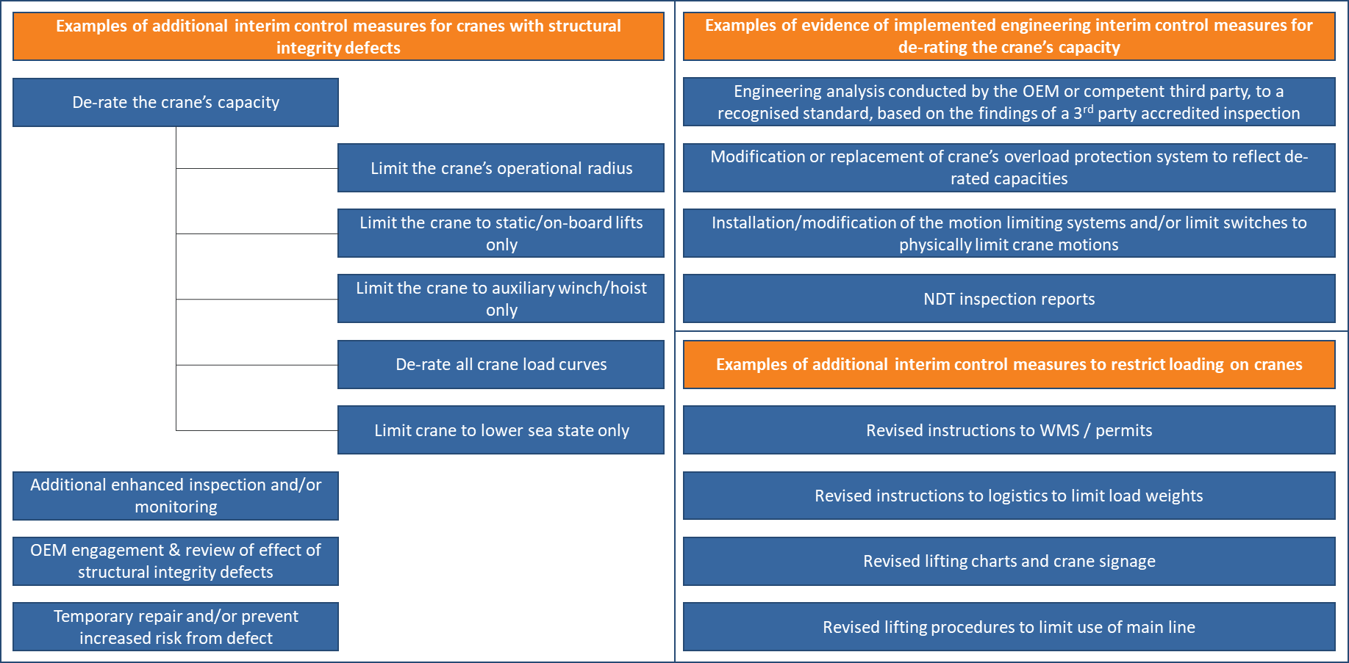

Key lessons

Offshore cranes are Safety-Critical Equipment (SCE), the failure of which could cause or contribute to a major accident event. The structural failure of a crane could cause the crane to collapse and/or a load to be dropped with significant consequences.

If a crane is defective, it should be immediately taken out of service.

Cranes may be put back into service in a de-rated capacity with appropriate management of the hazards associated with the defects. Higher-order controls (e.g. engineering) are preferable over administrative controls.

The defects must be rectified promptly, and the crane returned to its original condition as soon as practicable. If this cannot be achieved, the crane should be taken out of service.

NOPSEMA recently published guidance on ORA (N-04300-GN1818 ‘Operational Risk Assessment’). The following should be noted for offshore cranes and their de-rating:

* The operator of a facility has a regulatory obligation to operate their facility in accordance with the accepted safety case and the standards nominated therein. For example, these standards would include design, maintenance, and operating standards for offshore cranes.
* Operators should cease activities where controls do not meet requirements specified in the performance standards. For example, a crane with heavy corrosion may not be able to safely lift its rated capacity.
* Operating with impaired SCE and without adequate additional interim control measures may be considered as operating contrary to the safety case. For example, operating a de-rated crane without additional reasonably practicable risk mitigation control measures such as modifying the overload prevention system.
* Operators should have an ORA system in place to assess the risks posed by impaired SCE performance. They should also identify and implement additional interim control measures to cover the period until full functionality of the SCE is restored.

Utilising the crane’s manufacturer or a crane specialist engineer to assess risks in operating a crane with structural or mechanical integrity issues is good industry practice. These parties should have the required technical skills and independence to provide an unbiased assessment and may help to determine what additional interim control measures may be appropriate for the specific crane.

Some of the following activities would be considered evidence of a robust process to temporarily de-rate a crane as part of the process, which contributes to the continued operation of a de-rated crane:

* An engineering analysis to a recognised crane design standard, conducted by the OEM or crane engineering contractor, to determine the impact of the known issue on the crane’s structural and/or mechanical integrity.
* An assessment of the repair and an estimate as to how long the crane shall be de-rated.
* Implementation of temporary repairs to prevent further loss of integrity.
* Identification and implementation of suitable technical and other control measures to prevent the   
  de-rated crane from being overloaded. For example, an overload protection control system with the revised load chart programmed.
* Modification of the existing maintenance and/or an enhanced inspection regime for the crane that takes into account the degradation mechanism that led to the requirement to de-rate the crane.

Legislation

Clause 9 (2)c) of Schedule 3 to the *Offshore Petroleum and Greenhouse Gas Storage Act 2006* places specific duties on the operator of a facility to take all reasonably practicable steps to ensure that any equipment, such as lifting equipment, is safe and without risk to health. NOPSEMA would like to draw operator’s attention to our previously published guidance on damage to SCE (N-09000-GN1914 ‘Damage to Safety-Critical Equipment’) and the requirement to notify NOPSEMA.

References

* [NOPSEMA guidance note N-04300-GN1818 Operational Risk Assessment](https://www.nopsema.gov.au/assets/Guidance-notes/A639100.pdf)
* NOPSEMA guidance note N-09000-1914 Damage to Safety-Critical Equipment
* HSE Guidance on beyond lifetime criteria for offshore cranes
* DNVGL-ST-0378 Standard for offshore and platform lifting appliances
* API RP-2D Operation and Maintenance of Offshore cranes
* Lloyds Register – Code of Lifting Appliances in a Marine Environment
* EN 13852-1 Cranes – Offshore cranes – Part 1: General purpose offshore cranes
* BS 7121 Code of practice for safe use of cranes – Part 11: Offshore cranes